LEAVE REPORT
EMPLOYEE
INSTRUCTION MANUAL

Introduction
Web Time Entry is the new time keeping method for employees at MSU. Employees will be responsible for entering and submitting their hours worked every pay period. From that point, the supervisor will be responsible for approving the hours worked. Once the supervisor has approved the hours, they will then be processed by Payroll.

It is solely the responsibility of the employee to enter and maintain an accurate representation of the hours worked. If hours are not submitted on time, they will not be processed by Payroll for that pay period. Hours submitted late will require manual entry and will not be processed until the next pay, thereby causing the employee’s paycheck to be delayed by an additional two weeks.
Definitions of Time Sheet Period Status’:

Not Started - The employee has not viewed or entered hours
for this pay period.

In Progress - The employee has viewed or entered hours, but
have not submitted the hours/leaves.

Pending - The employee has submitted hours and awaiting
approval from the approver.

Approved - Approver has approved the hours.

Completed - The hours have been extracted into the payroll
process.

Return for Correction - The approver found an error/incorrect hours entered
on the time sheet. Employee needs to make changes
and submit again.

A. Instructions

1. Logging On

a) From the MSU Home Page click on” myMWSU” upper left side.

b) Log on to the Self-Service Banner (SSB) by selecting “Portal Login Not Working?”
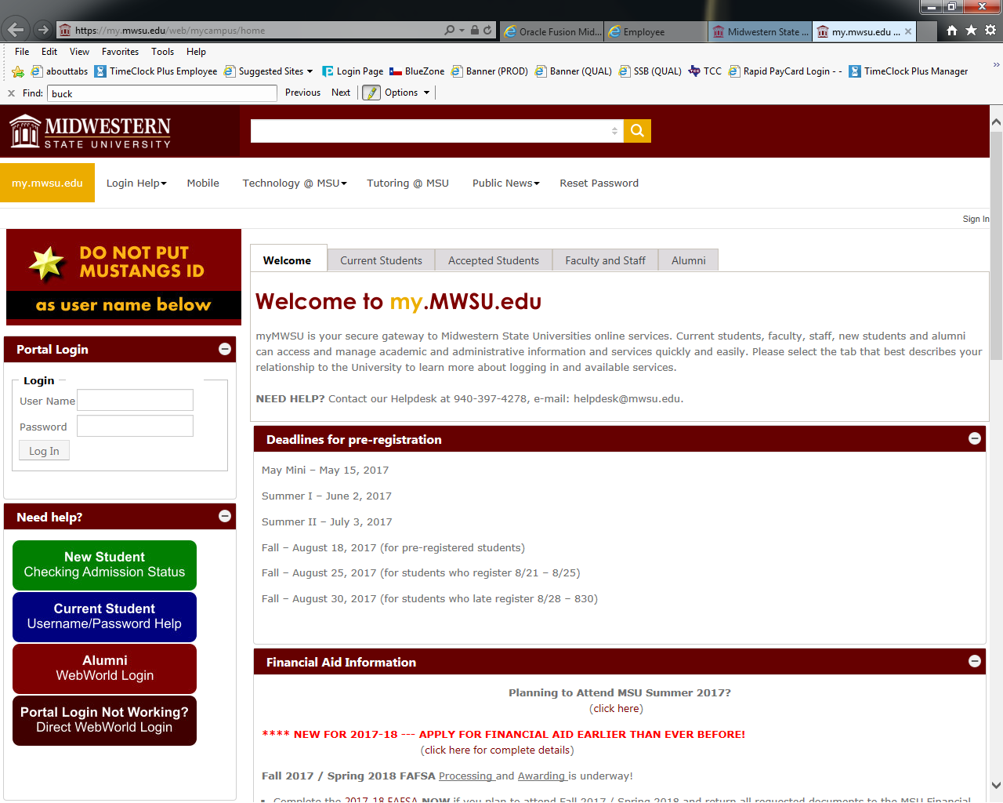

2) Enter User ID and Pin. (User ID “M” must always be capitalized) If you don’t know your Pin or it’s expired then Contact Payroll to have it reset (940-397-4230).
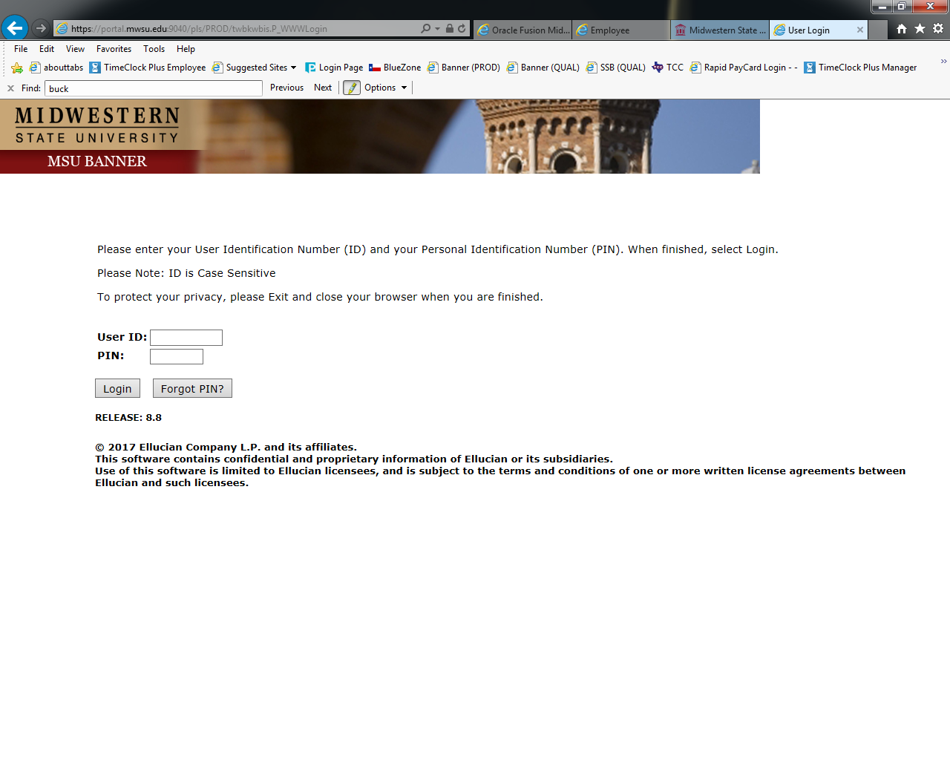
Click “Employee”

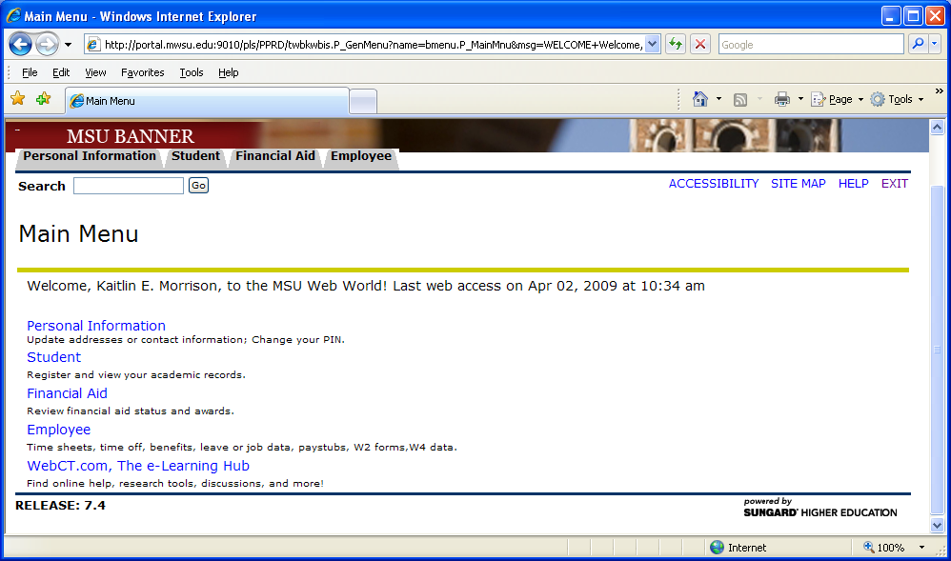

Click “Leave Report”

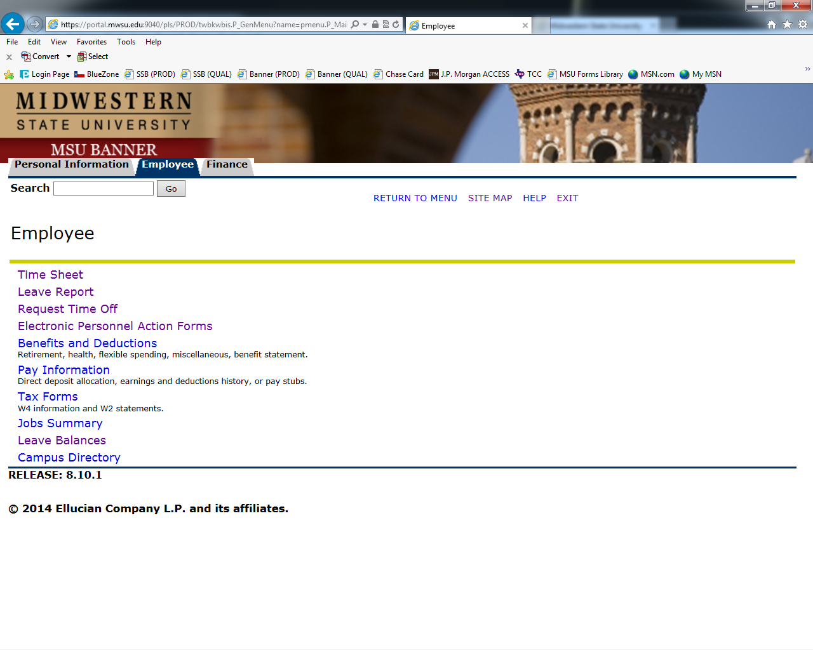

From the dropdown box select the appropriate month that you are reporting leave, click “Leave Report”

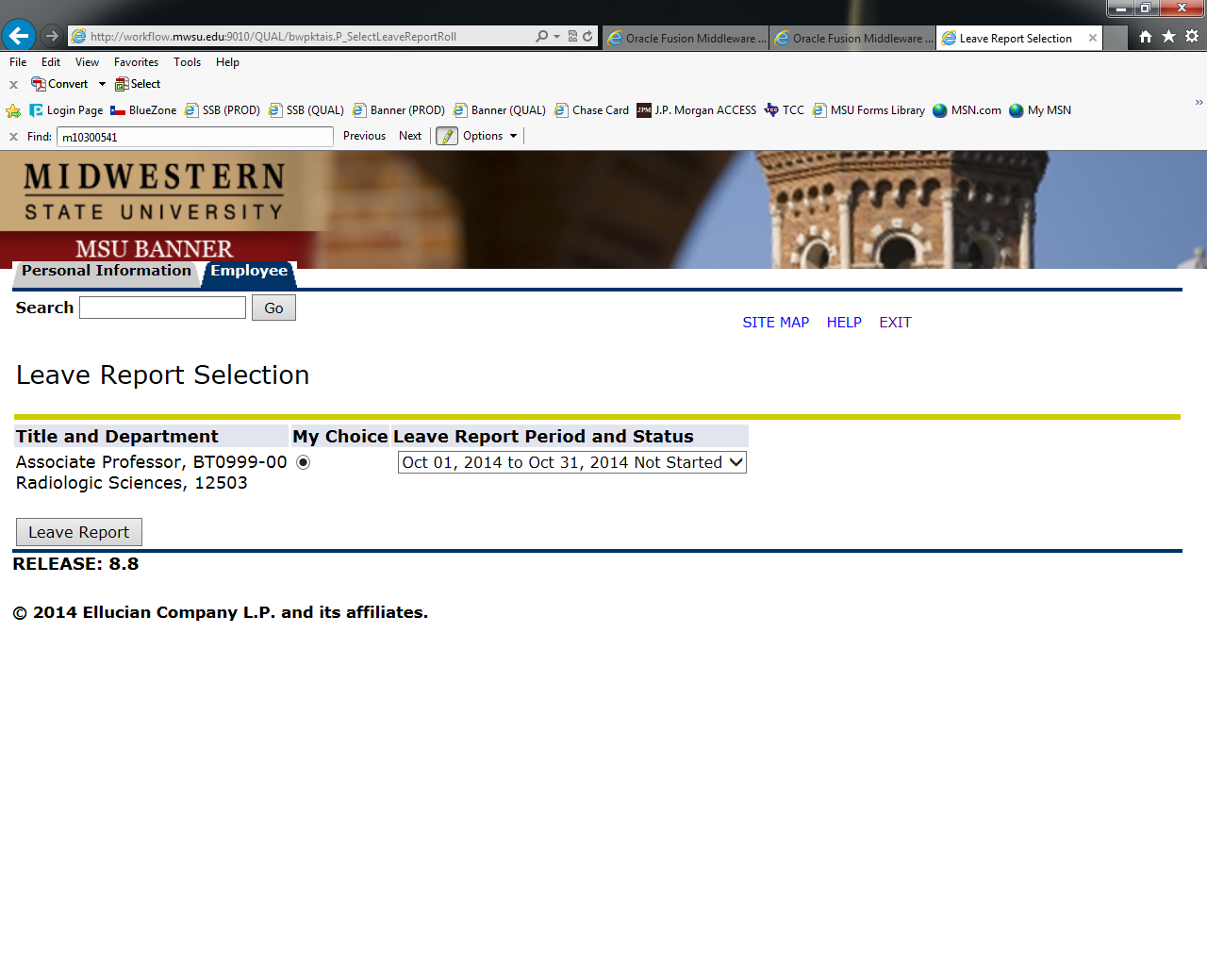

a) If you have no leave to report, click “Submit for Approval”
b) Select “Next” to enter hours for the next weeks.
c) Select “Comments” if you wish to add a comment

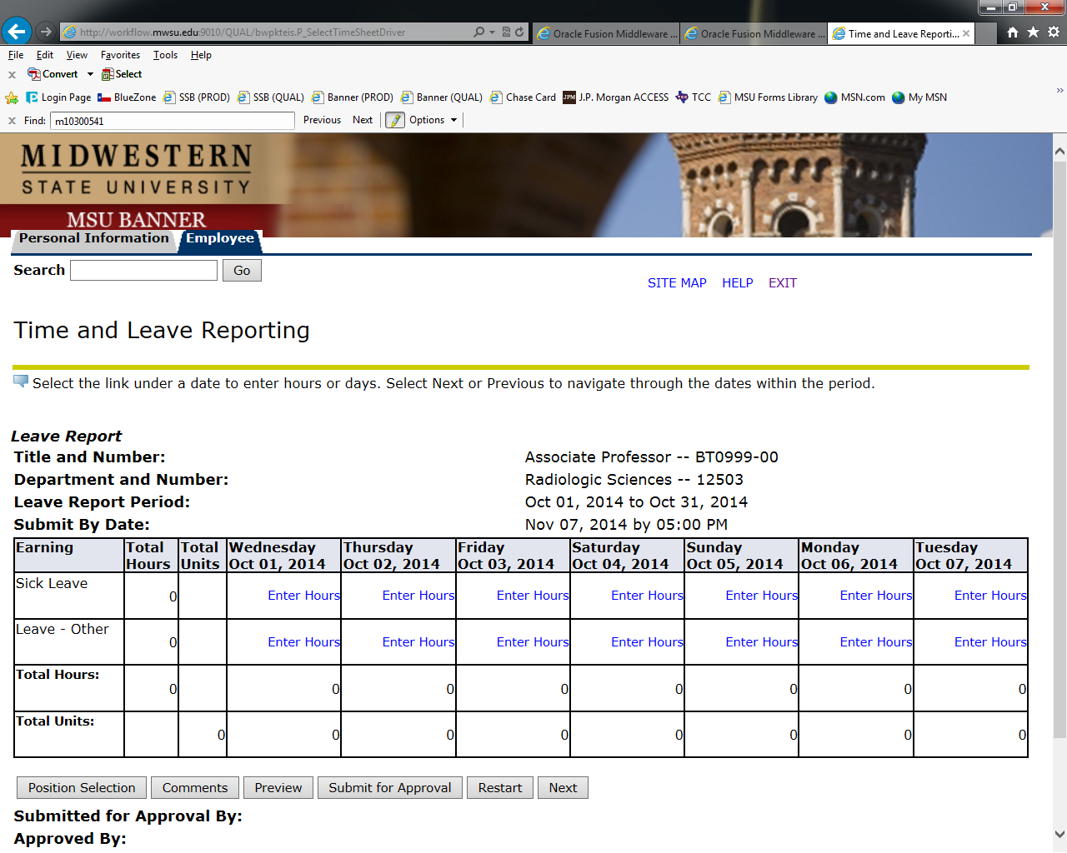

To enter hours click “Enter Hours” on the day you are reporting leave, enter hours, click “Save”

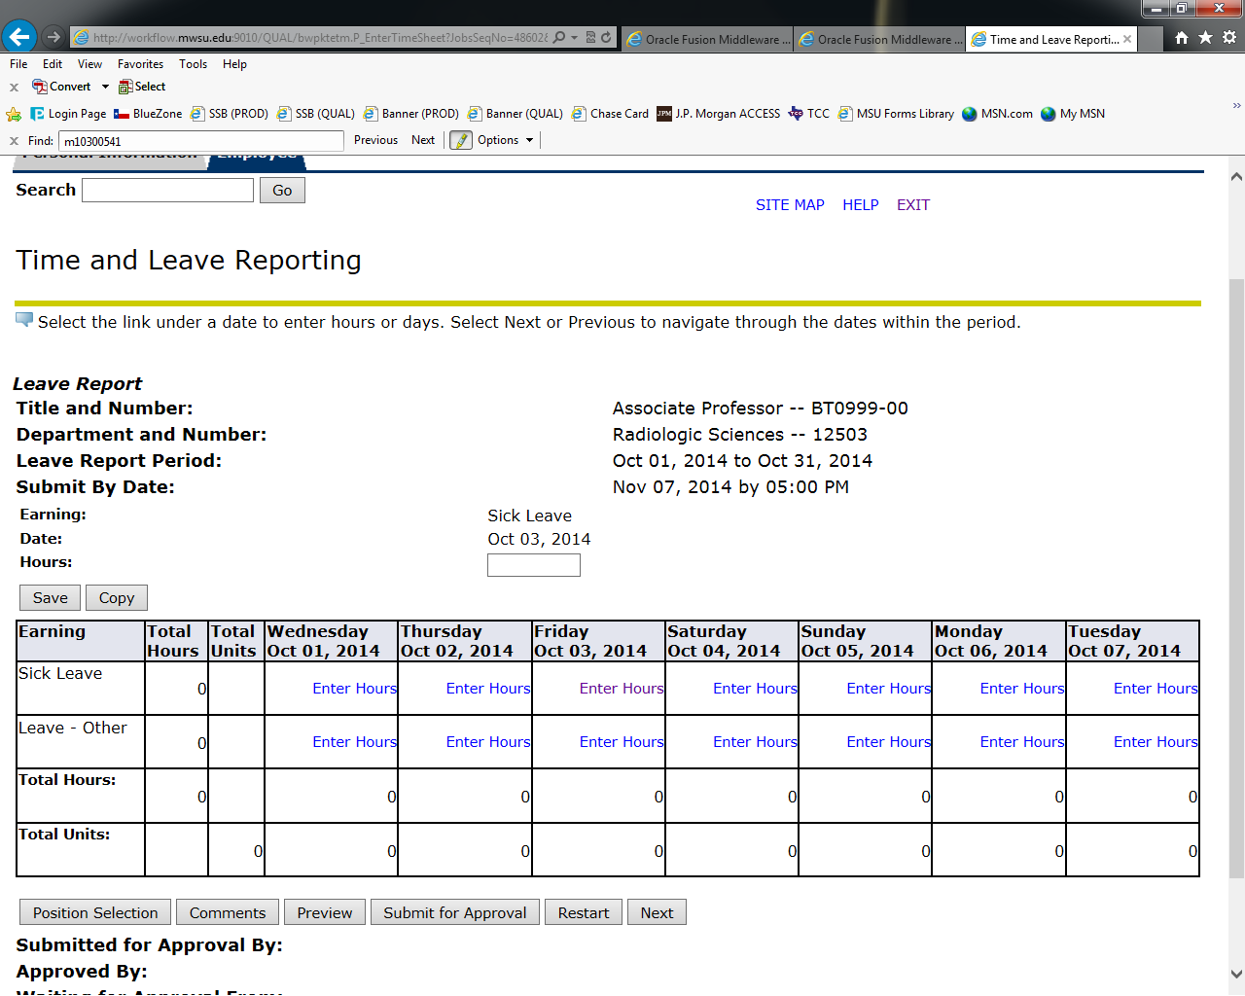

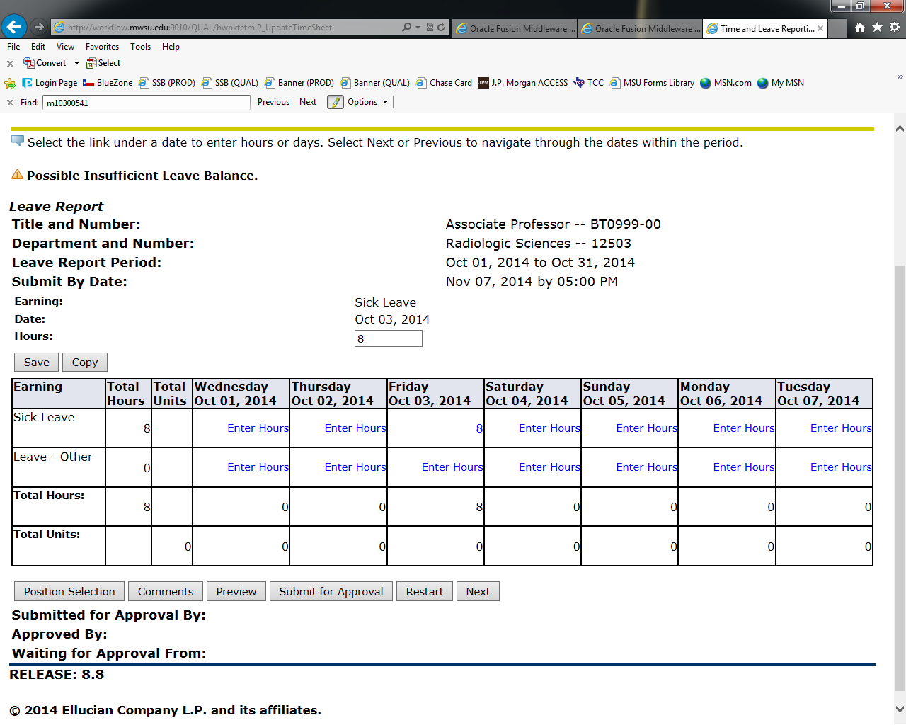

If you need to enter hours for more than 1 day, click on the first day, enter hours in the box, click “Copy”. Click each day you are reporting and click “Leave Report” and the days will be populated.

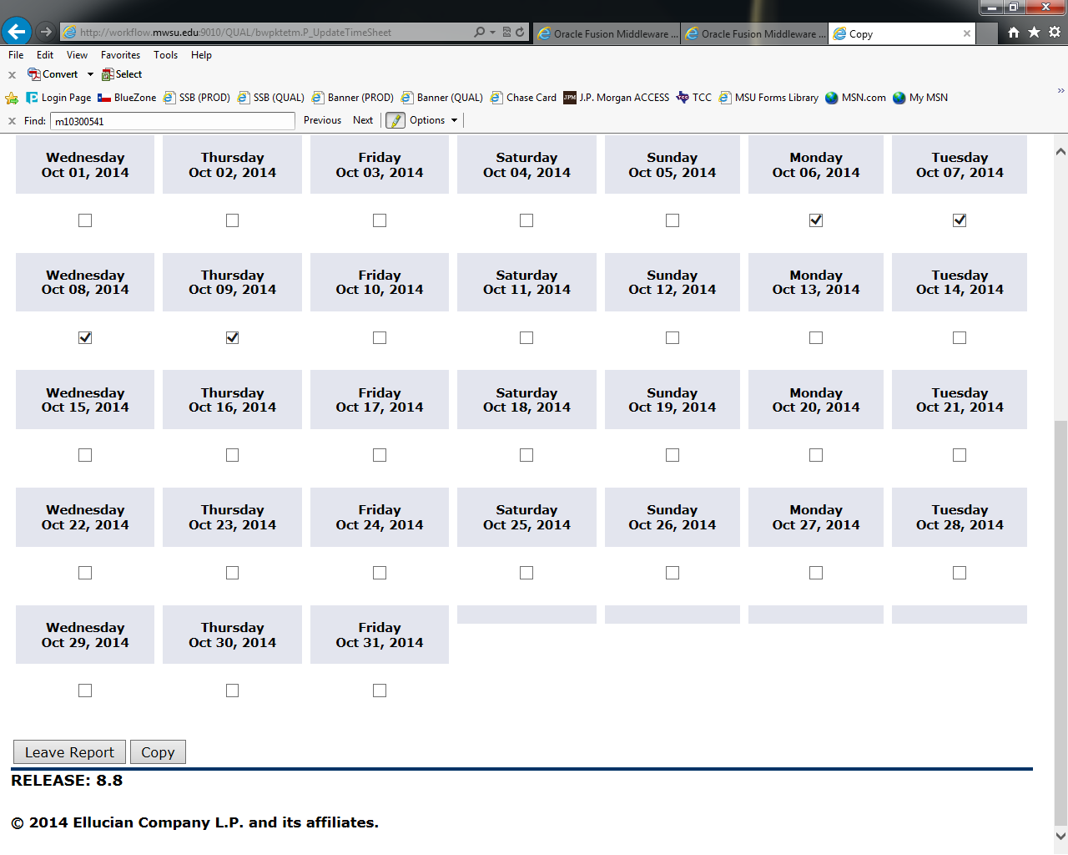

Once you have completed, click “Submit for Approval”

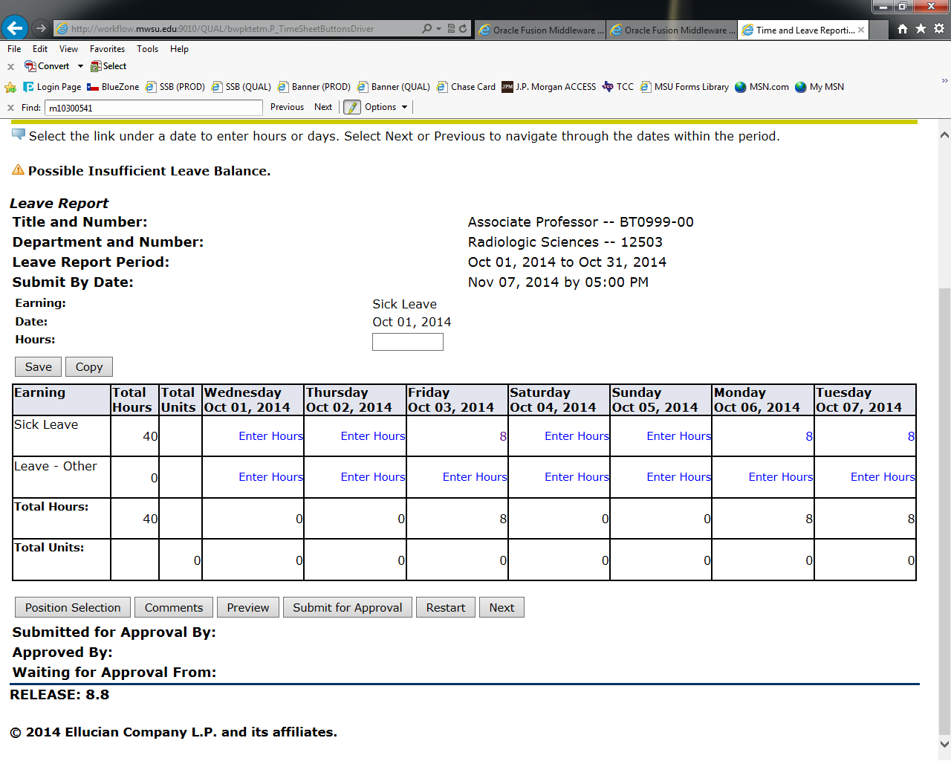
Electronic Signature: Enter the same PIN you logged in with.

